**Pratima Bhattarai**

**Lab 2**

Questions:

1. Is your browser running HTTP version 1.0 or 1.1?

HTTP is running version 1.1 in my browser.

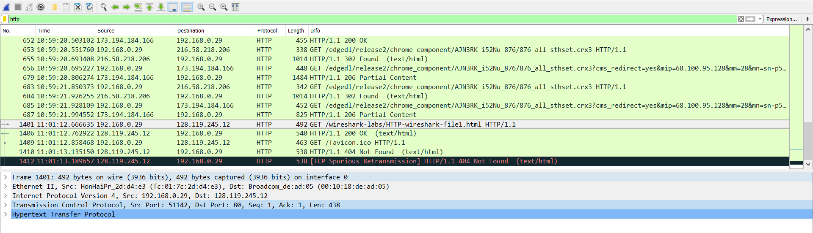

1. When was the HTML file that you are retrieving last modified at the server?

The HTML file that was modified last at the server on Friday, 14 sep 2018 at 10:36:26 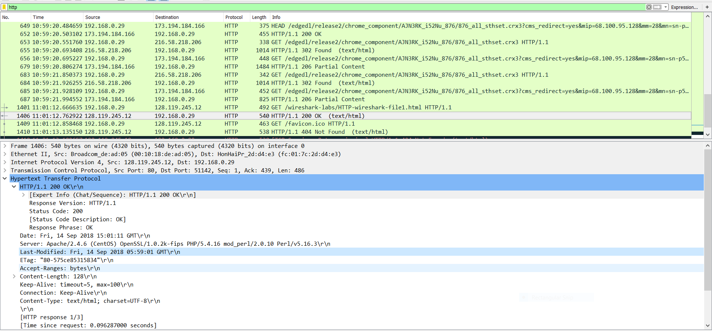

1. What is the IP address of your computer? Of the gaia.us.umass.edu server?

The IP address of my computer is 192.168.0.29 and of the gaia.cs.umass.edu server is 128.119.245.12.

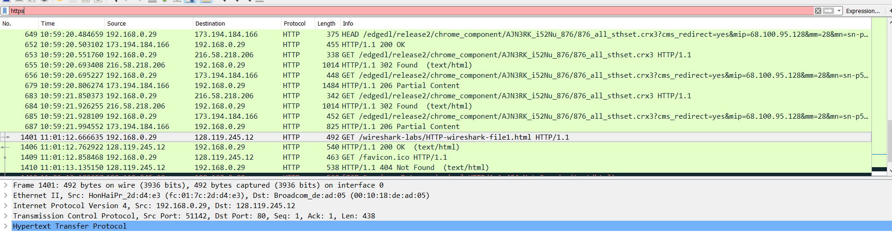

1. What languages (if any) does your browser indicate that it can accept to the server?

The language that my browser indicate is English.

